Introduction of Video Consulting at Ardach Health Centre
From May 2019 a Project Team was formed with members of the Multi Disciplinary Team and Patients from across the Practice. By trialling this System with patients at the heart of its developing phases we gathered feedback and reviewed data which influenced the team to shape and change things over several months.
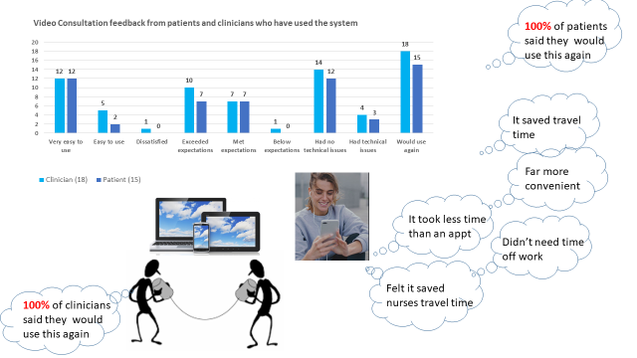

Video Consulting is currently being used by a number of different professionals across the practice. Contacts have include Planned GP Reviews, Chronic Disease Reviews, Duty Team Triage including Mental Health; Stress and Distress, Children, Skins Conditions and Pharmacy Reviews.

We recognise there is a place for all types of consultation and one way to consider which may be the most suitable for you is to ask yourself:

- Do I need to show something, but it does not require a physical examination? – video consulting may be suitable
- Do I only need to hear/talk? – telephone may be suitable
- Do I need examined, or tests carried out? – face to face consultation remains important and necessary when a patient requires examined and if there is a complex clinical need/possible need for further or urgent tests and investigations.

Going forward, if you feel a Video Consultation could be appropriate for you, please discuss this with the clinical member of the team that you are seeing to plan your review appointment. Equally you can discuss with our admin team who can give you advice and support, as required, on booking a routine video consulting appointment as an alternative to a face to face appointment.
Attending your appointment via a video call at Ardach Health Centre  Where appropriate, you can have your consultation online via a video call.  Video calling is as convenient as a phone call, with the added value of face-to-face communication.  It can save you time and money, and brings your care closer to home.  Where do I go to attend my appointment?  To attend your appointment, go to:  https://www.ardach.org.uk/  Press “Video Consulting” link on homepage if using a laptop or computer. If you are using a mobile device, iPad or tablet please click on the three bar tab at the top right of your page and scroll to the bottom and press “Video Consulting”.  Instead of travelling to your appointment, you enter the waiting room at your appointment time.  The health centre is notified when you arrive, and your clinician will join you when ready.  There is no need to create an account. No information you enter is stored.  What do I need to make a video call?  - A good connection to the internet If you can watch a video online (e.g. YouTube) you can make a video call  - A private, well-lit area where you will not be disturbed during the consultation  - One of these:  - Google Chrome web browser on a desktop or laptop (Windows or MacOS), or on an Android tablet or Smartphone  - Safari web browser on an Apple desktop or laptop (MacOS), or iPad or iPhone  - Web-camera, speakers and microphone (already built into laptops or mobile devices) | Mr John Coull plans his review appointment from home with Dr Green when appropriate.  Is it secure?  Video calls are secure; your privacy is protected. You have your own private video room that only authorised clinicians can enter.  £ How much does a video call cost?  The video call is free (except for your internet usage).  How much internet data will I use?  You don’t use any data while waiting for a clinician to join you. A video consultation uses less than half of the data you would use while watching a YouTube video in High Definition*.  Data use is less on lower-speed internet connections, or if you’re using a less powerful computer, tablet, or Smartphone. These factors can also reduce the overall quality of the call.  Data use increases when there are more than two participants in the call.  Smartphone & tablet users, if you can, connect to a home or work Wi-Fi network to avoid using your mobile data allowance.  *That's about 230 MB on a mobile device, and 450 MB on a PC for a 20 minute call, which is similar to Skype® or FaceTime®.

